

**Faculty of Green Energy and Technology**

**BACHELOR OF TECHNOLOGY (HONOURS) IN   
ELECTRONIC SYSTEMS**

**Work Based Learning - Machine Vision I**

**Assignment 4 Image processing research on image stack for 3D rendering**

1. **Anand Low Hong Ren 1801371**

**Introduction**

The objective of this assignment is to familiarize with Volumetric Analysis and Rendering Tool and to improve bad 3D rendering output by processing the stacks of 2D slice images so that the 3D rendering will improve. Volume rendering is a set of techniques which projects a 2D projection of a 3D discretely sampled data set. A 3D data set is a stack of 2D slice images acquired by a CT or MRI scanner. These are acquired in a regular pattern such as one slice every millimeter and usually have a regular number of image pixels in a regular pattern (The institute for digital archaeology, n.d.).With the 3D render, it is easy for the operator to observe any defects in the ball grid array. As an example, we can see in Figure 2 at the left side there are 2 balls sticking together which is a defect.

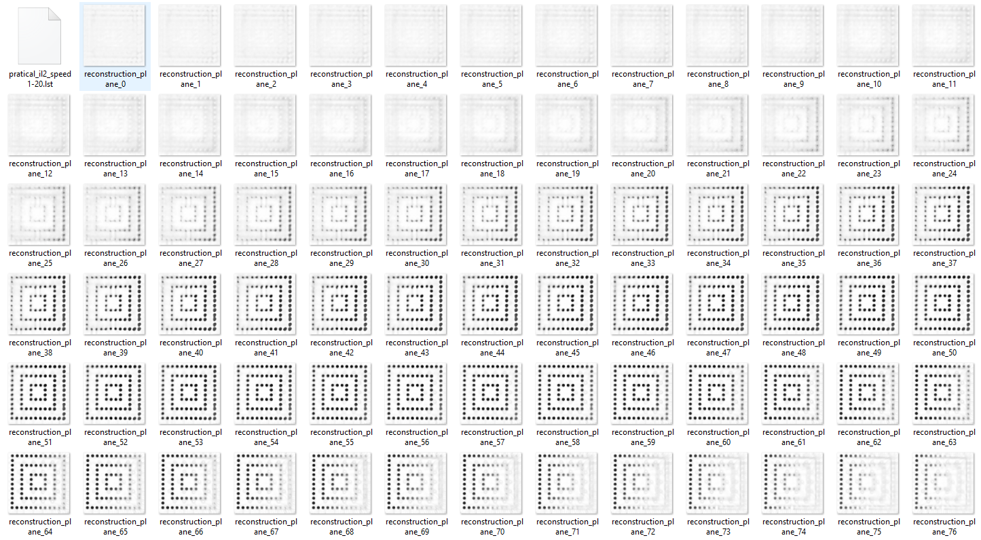

**Figure 1: slices of 2D image**

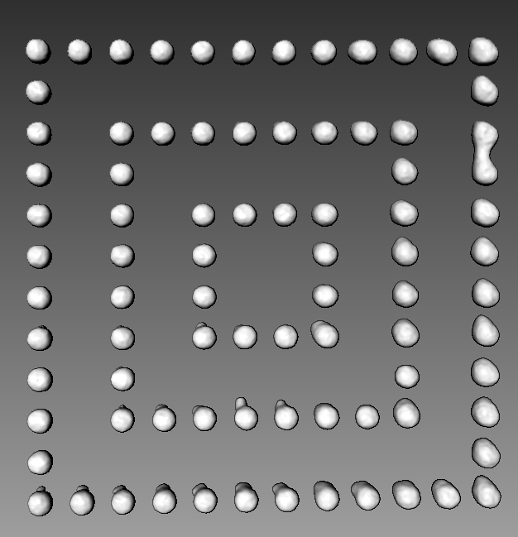

**Figure 2: 3D render of Figure 1 images**

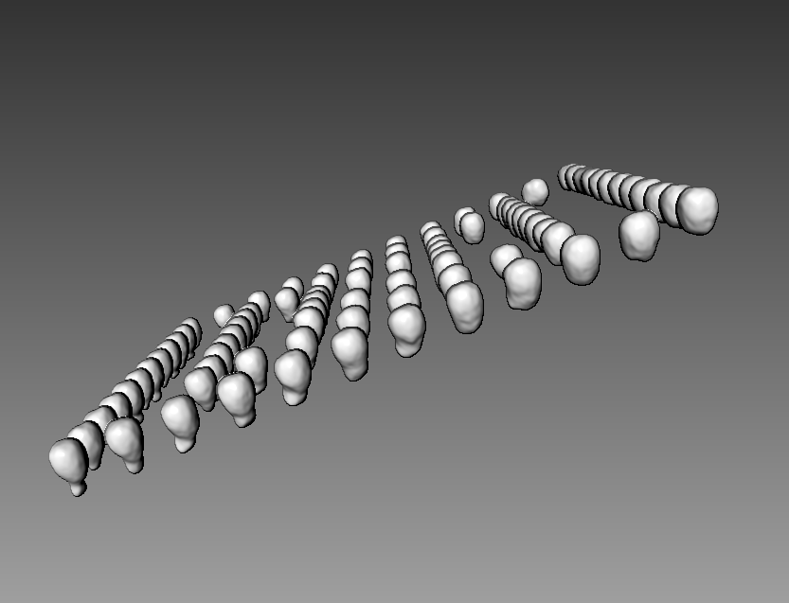

**Figure 3: 3D render of Figure 1 images 2**

**Methodology**

The stack of images that have a bad 3D rendering comes from board V. The stack of images and 3D renders are shown in Figure 4 and Figure 5,6 respectively.

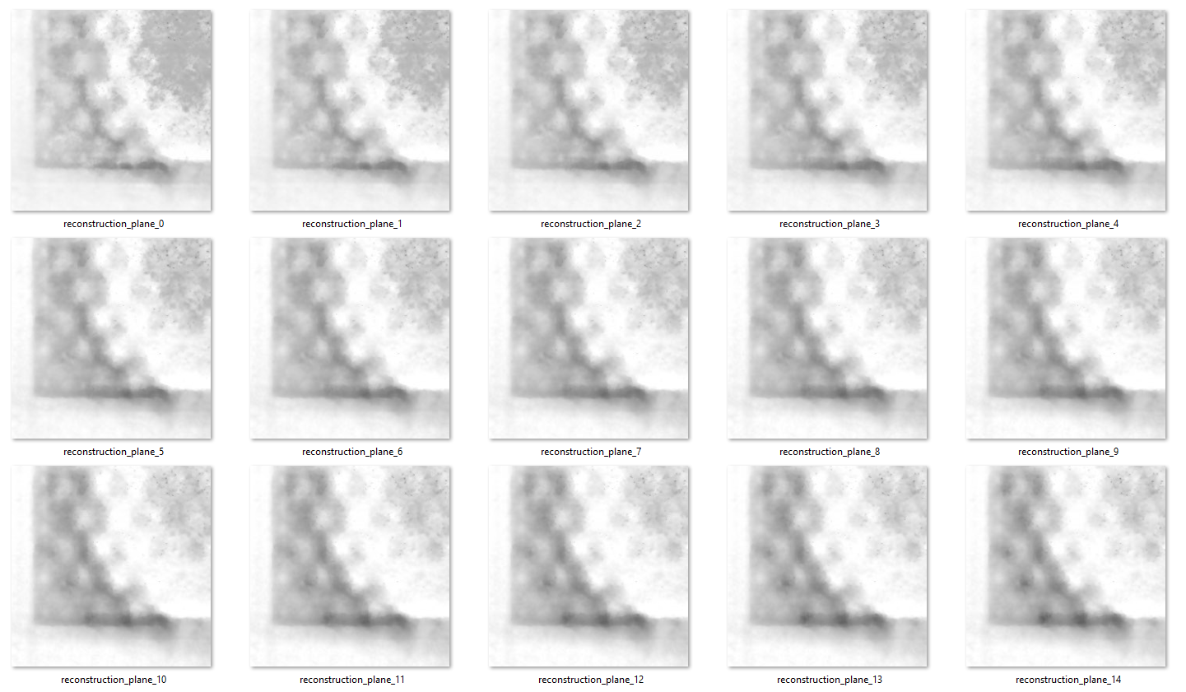

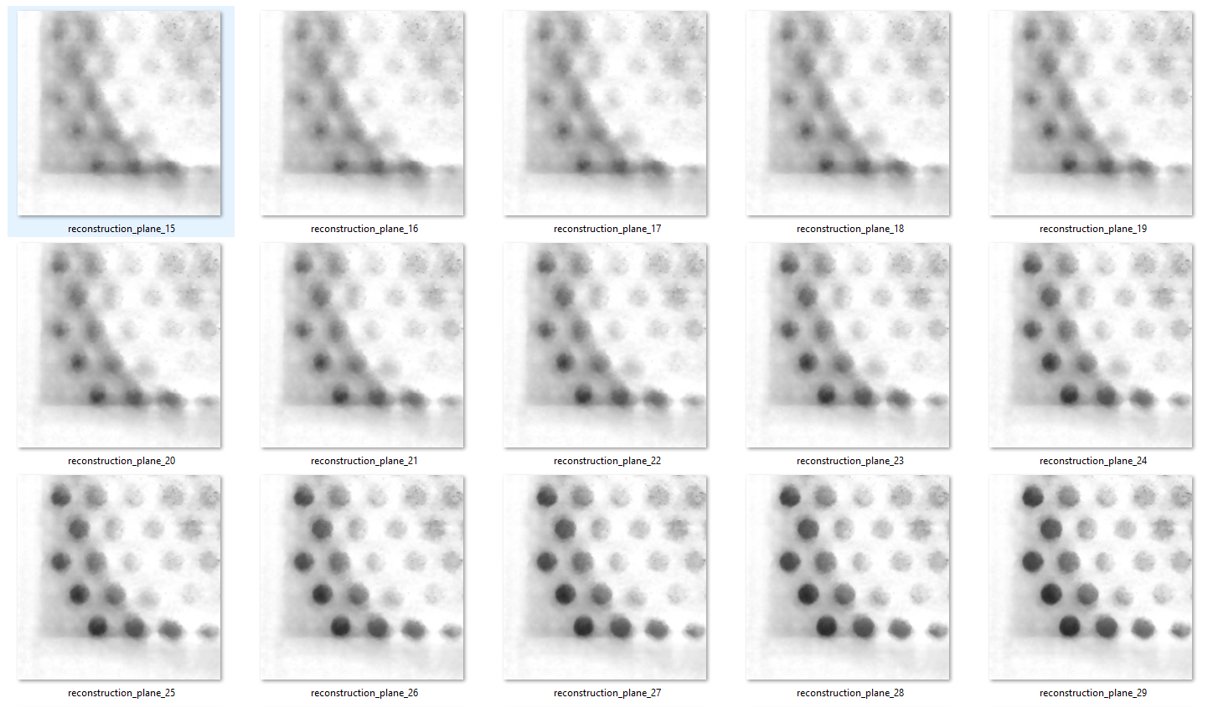

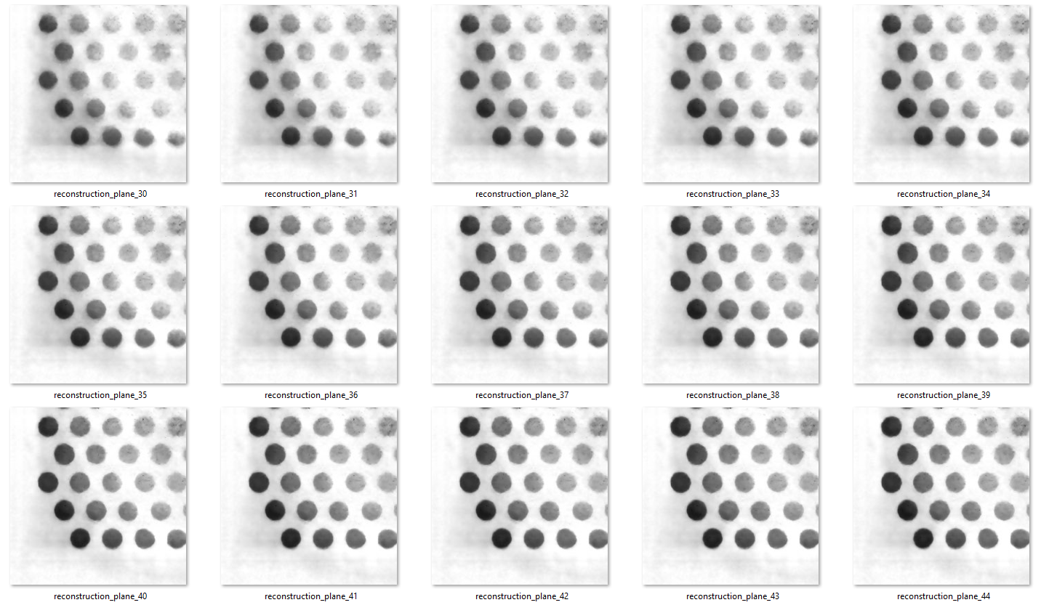

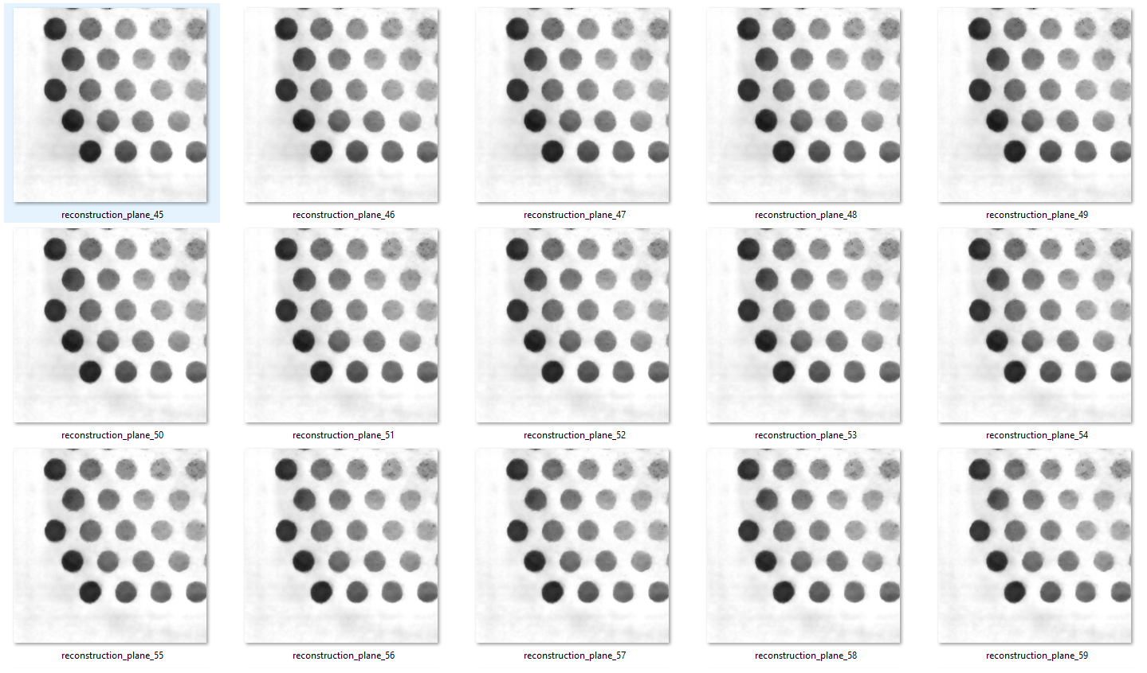

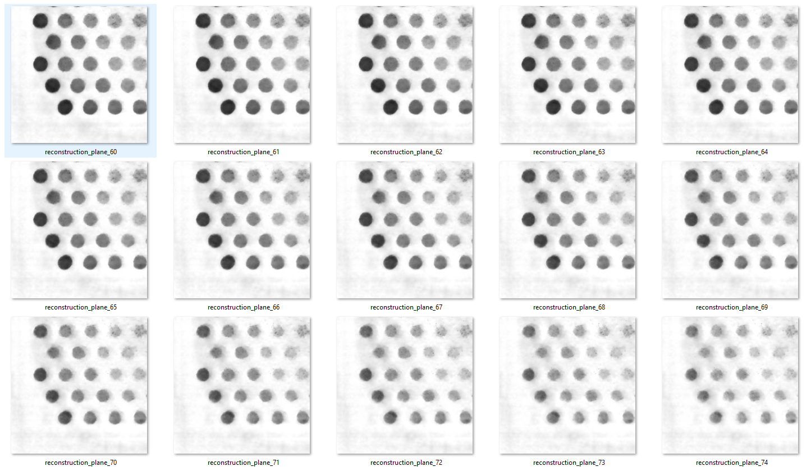

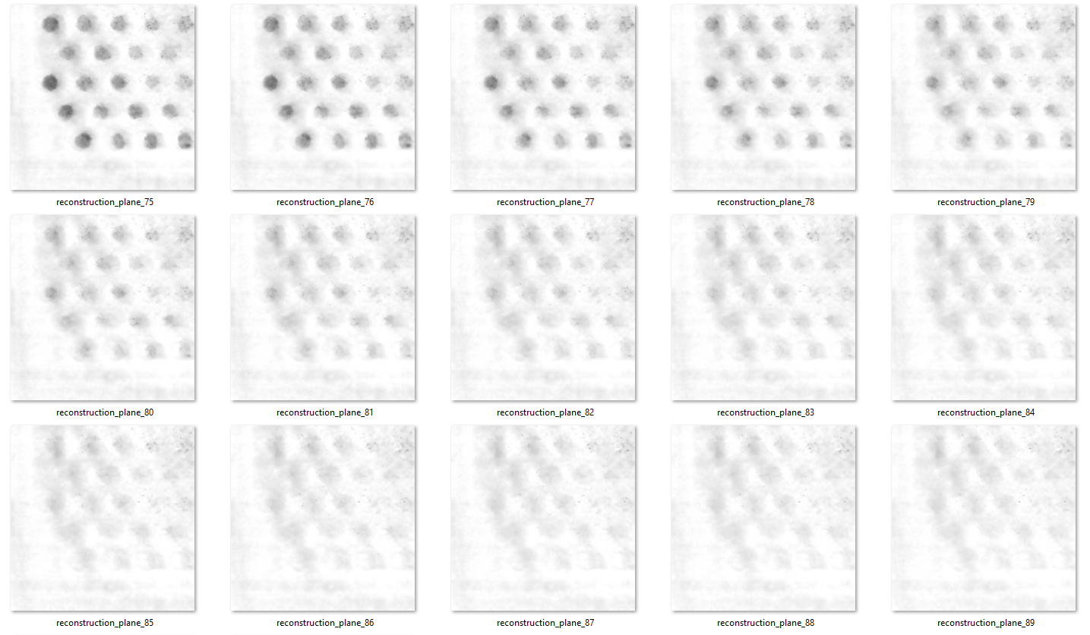

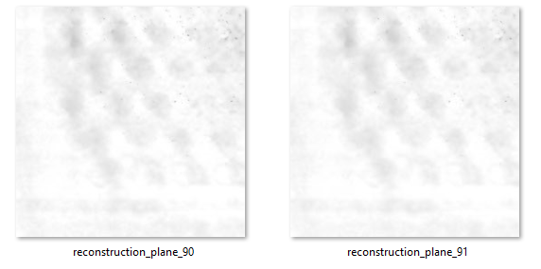

**Figure 4: Image stack board V**

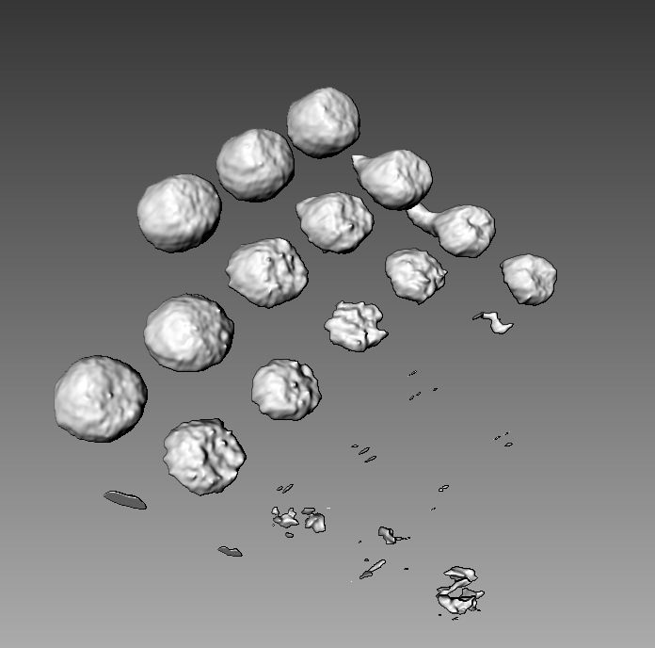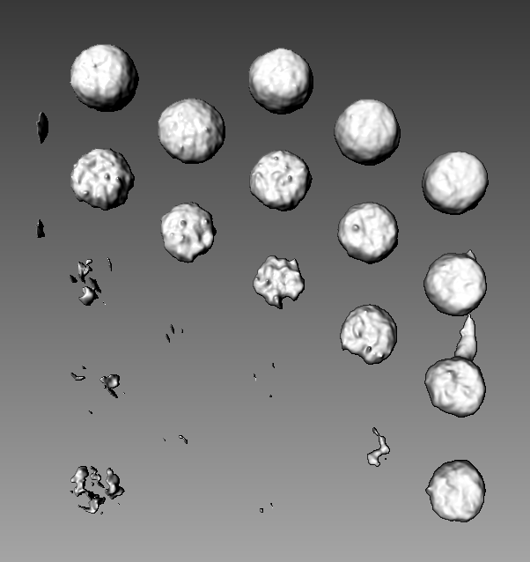

**Figure 5: 3D render (threshold value = 0 -135)**

As we can see in Figure 5, when threshold value is set to 135 we get perfect balls in some areas, however almost half of the balls are not showing up. The balls that show up are the black balls we can see very clearly in Figure 4, while the balls that did not show up are the lighter grey balls that are not very visible compared to the blacker balls. This is a problem we have to fix so that all balls show up nicely in the 3D render. In Figure 6, when I increased the threshold value to 0 - 205, the other balls showed up, however with some spikes on them and a lump connecting them below. The balls that are already present also connected by a lump shaped like a triangle.

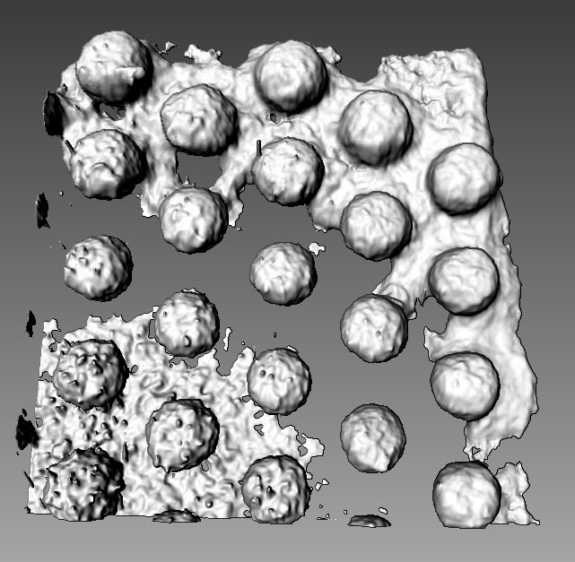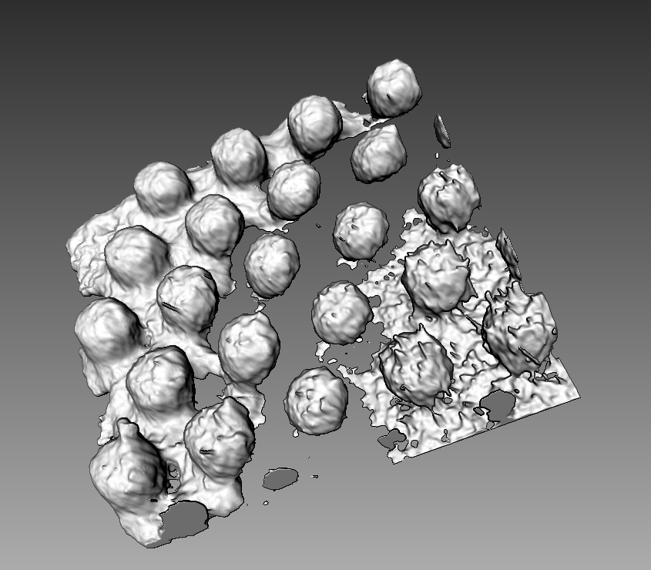

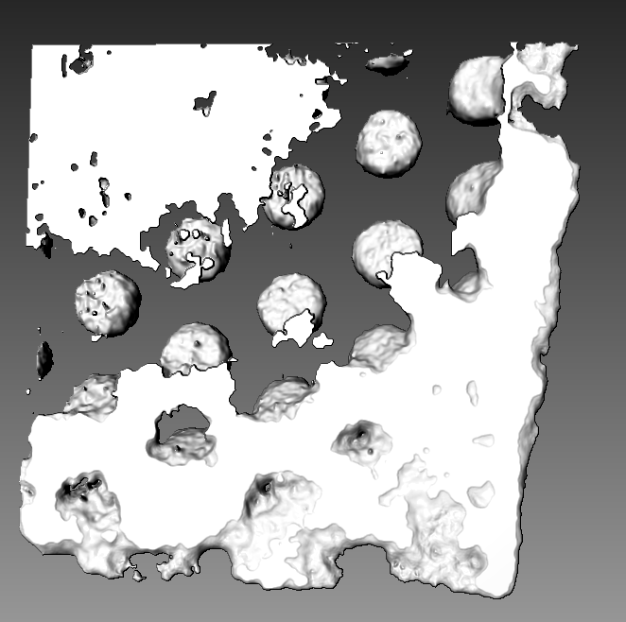

**Figure 6: 3D render (threshold value = 0 -205)**

The first step is to remove everything other than the ball grid array. First, a mask has to be created to filter the ROI (the balls from the background). The mask is made by thresholding the best slice which is reconstruction_plane_50.png. After thresholding, I used OpenCV findContours() to filter out everything except the balls. After that I use erosion to increase the area of ROI.

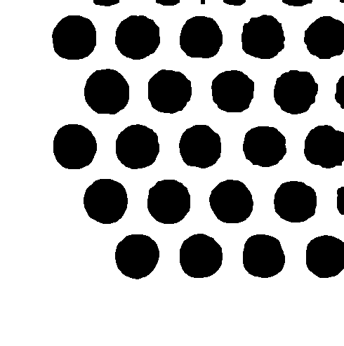

**Figure 7: Mask for image stack board V**

After that, The program keeps the black part in the original image and it erases the rest. The results are shown below.

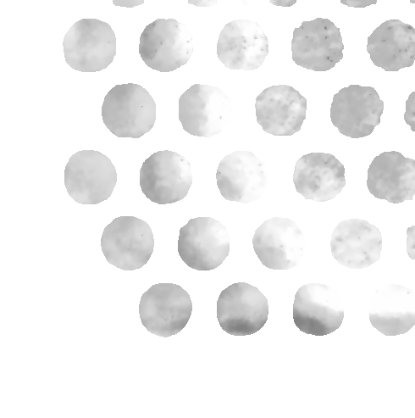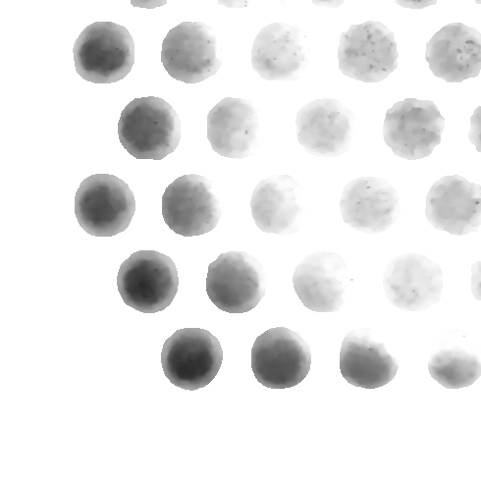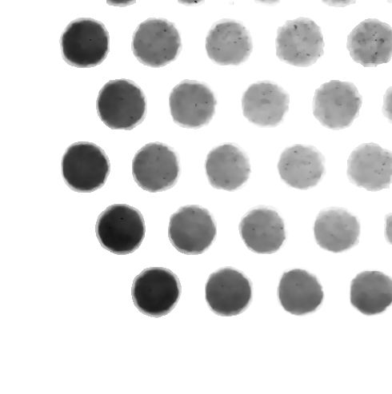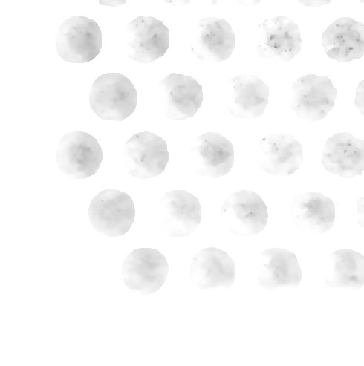

**Figure 8: stack of image after applied masking**

**Results and Observations**

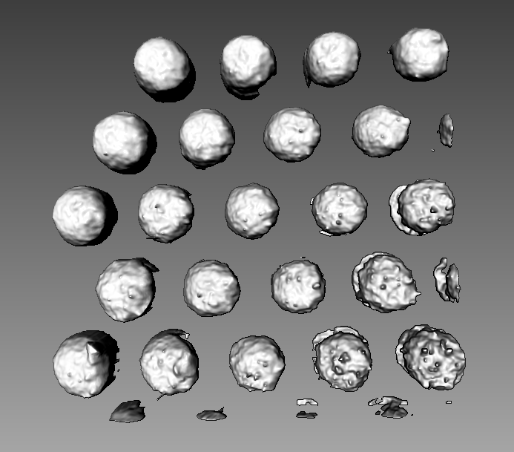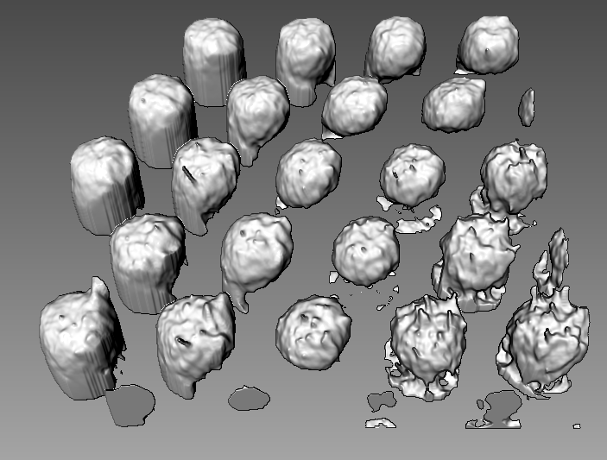

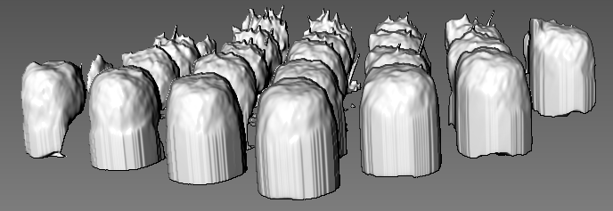

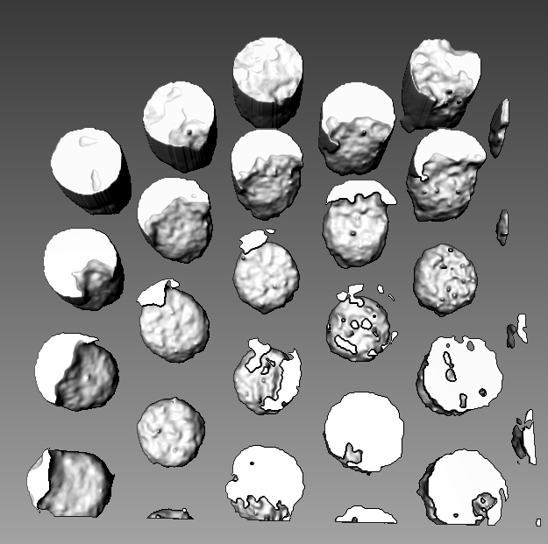

**Figure 9: 3D render after apply masking (threshold value = 0- 205)**

The results of the 3D render improve quite a bit. Even though they are not perfect balls, but each ball are separated from each other and the threshold can be set at 0-205 so that all the balls are visible. After applying the mask, I tried to add on other methods to improve the output 3D render. The first thing I tried is OpenCV image inpainting. OpenCV image inpainting is used to restore lost details in images. Some examples are shown in Figure 10. Image inpainting uses neighbour pixels to cover up marks so that the image is more complete.

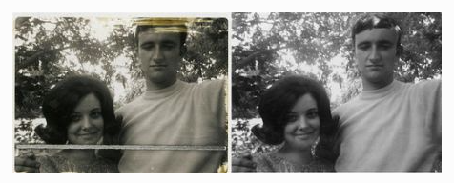

**Figure 10: Application of image inpainting**

As we can see below the images develop some kind of hexagon pattern around the balls. This pattern does not help at all with the 3D render.

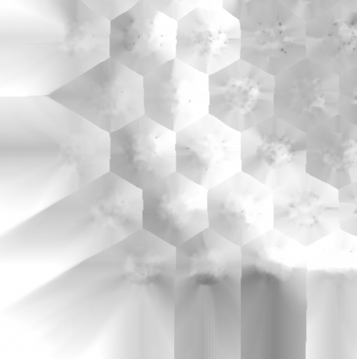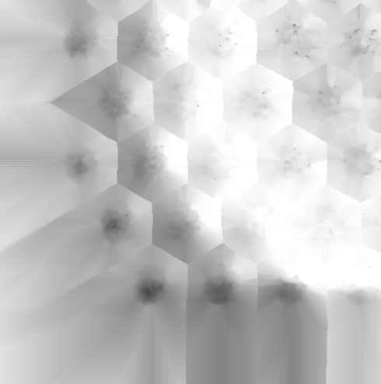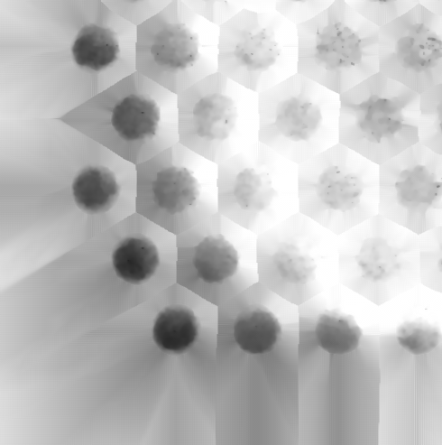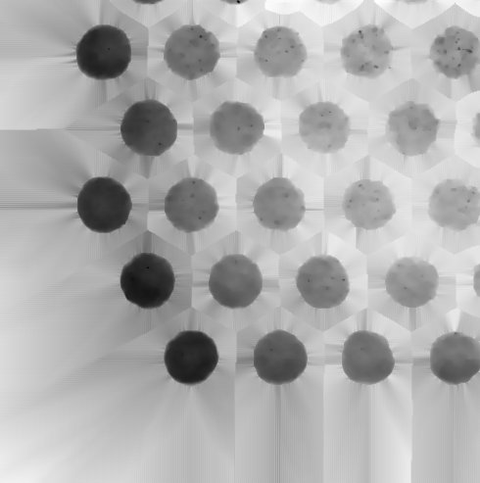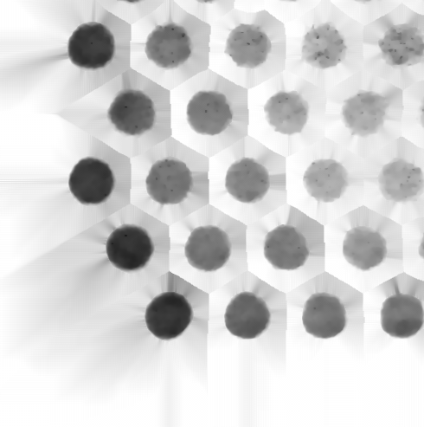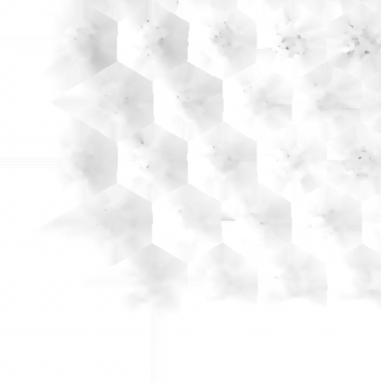

**Figure 11: Stack of images after applying image inpainting**

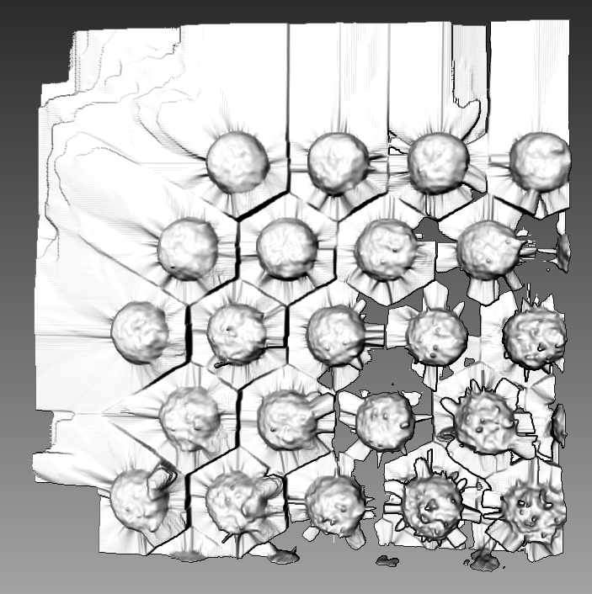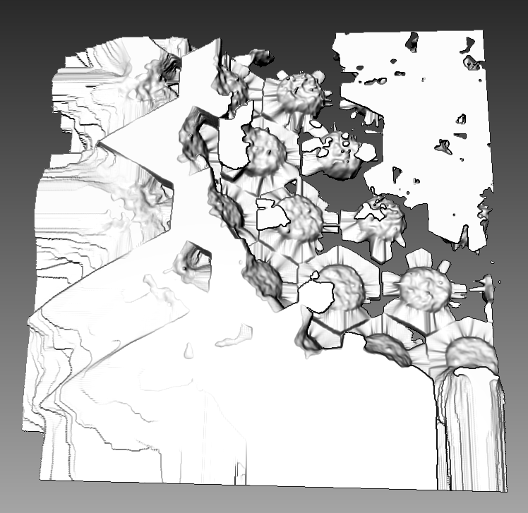

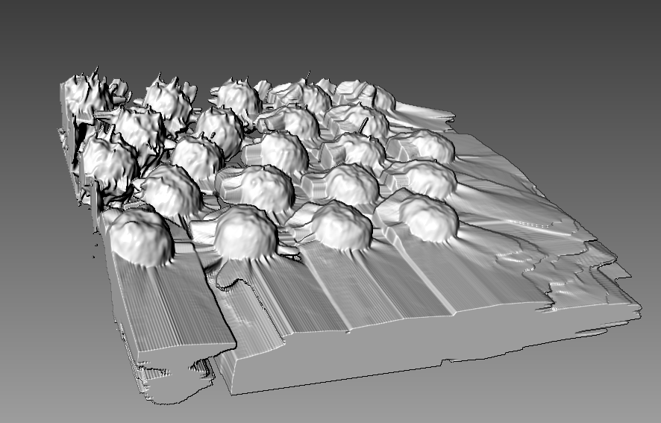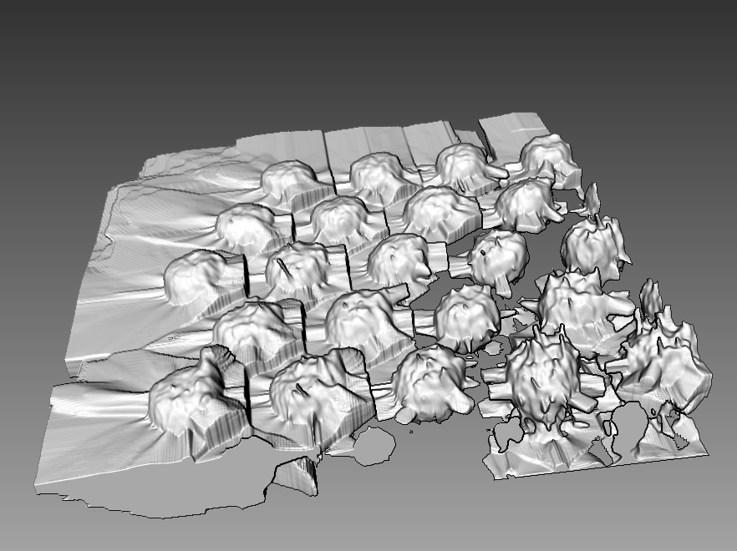

**Figure 12: 3D render after apply inpainting (threshold value = 0- 205)**

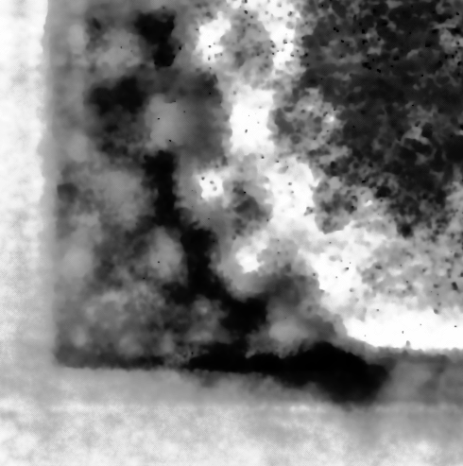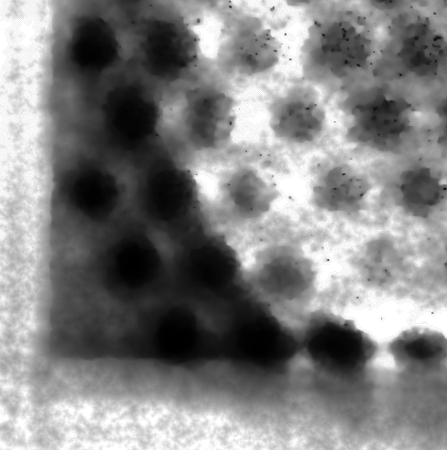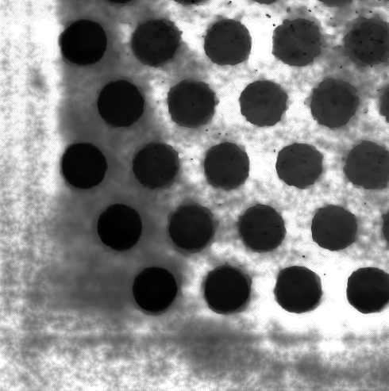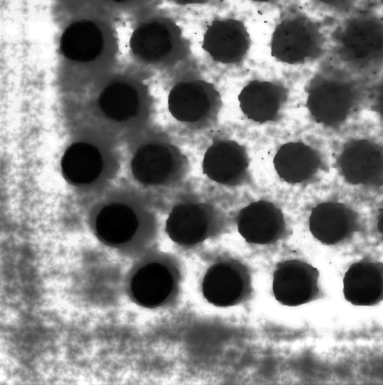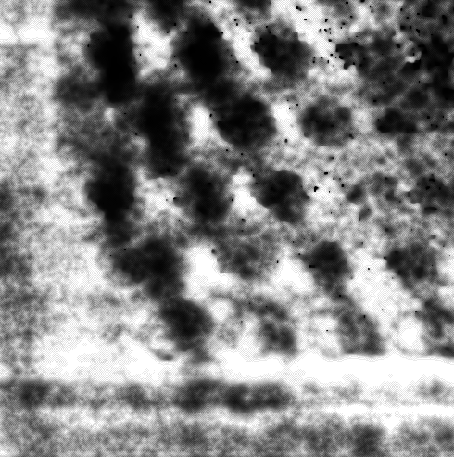

**Figure 13: Stack of images after applying histogram equalisation**

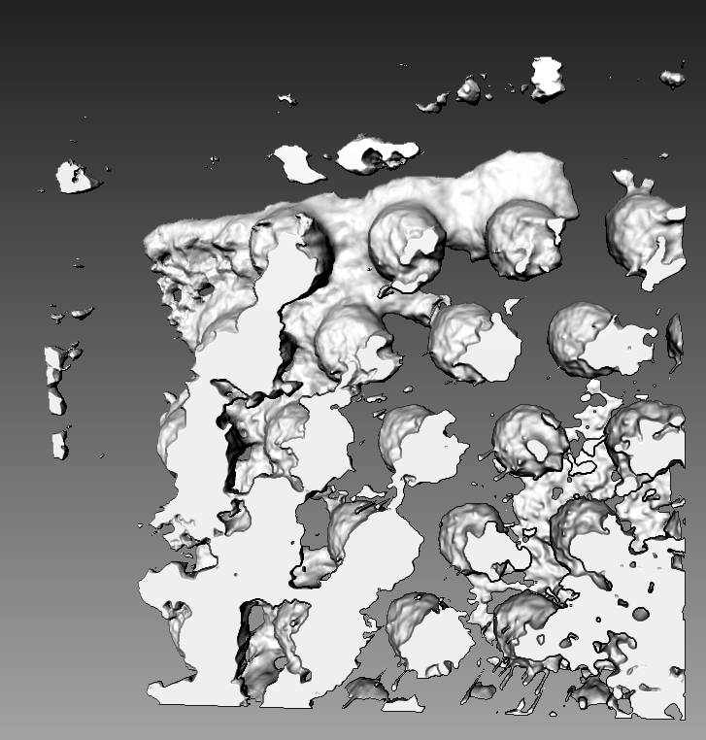 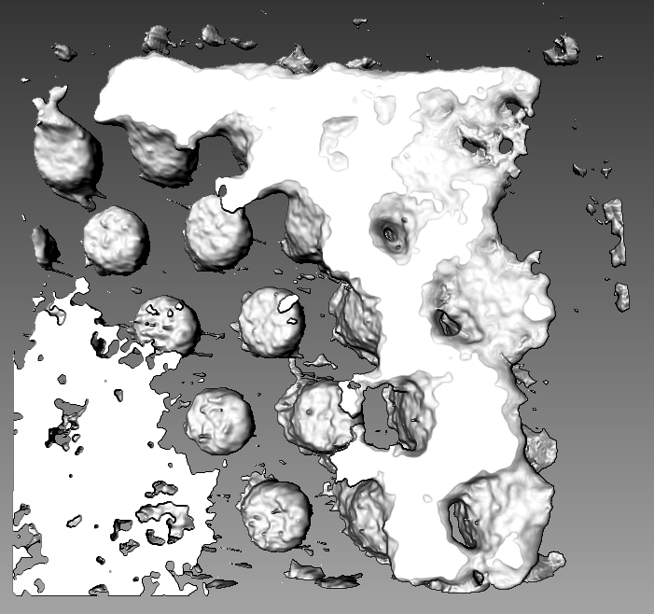

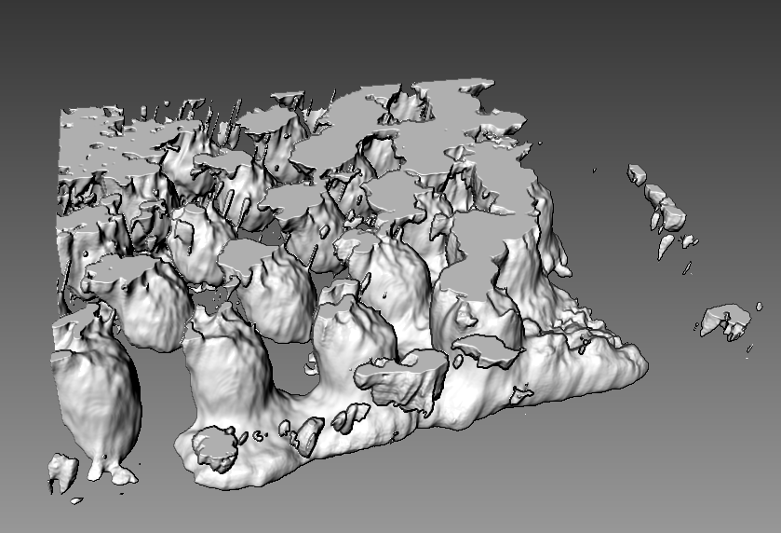

**Figure 14: Stack of images after applying histogram equalisation (threshold value = 0-68)**

In Figure 13, after we apply histogram equalisation, the hardly visible balls become more visible and become as black as the visible balls. However the background grey has also become much darker which will affect thresholding. In Figure 14, with the threshold value set lower at 0-68, all the balls are formed nicely, however the lumps created by the background affect visibility of the balls. From the side view, we are able to see that the texture of the balls are still there, so histogram equalisation is a viable way to make all the balls visible. However, further processing has to be made to improve the 3D render even further.

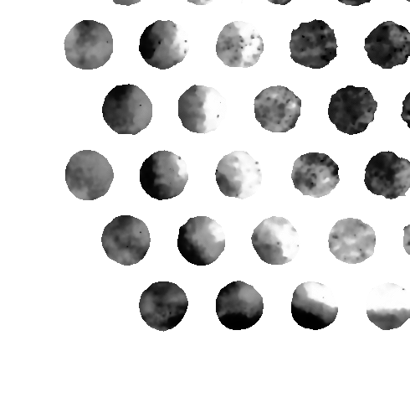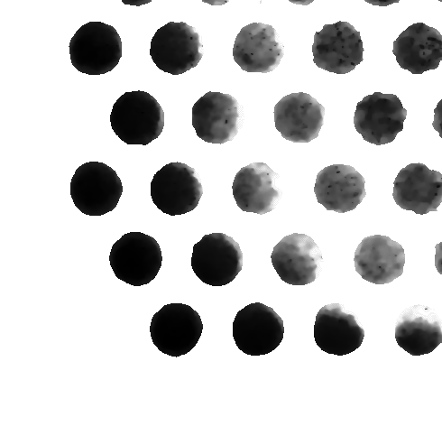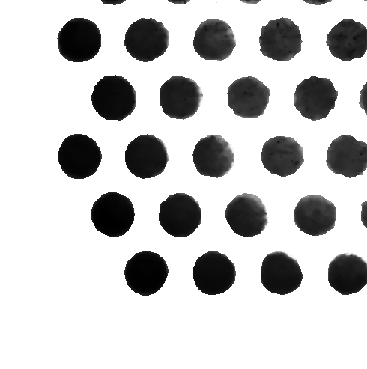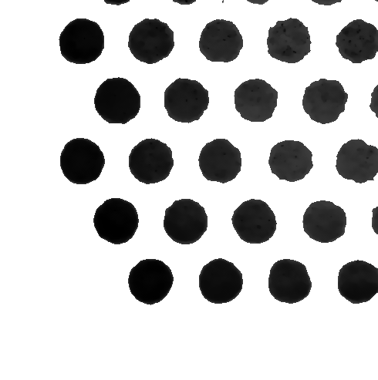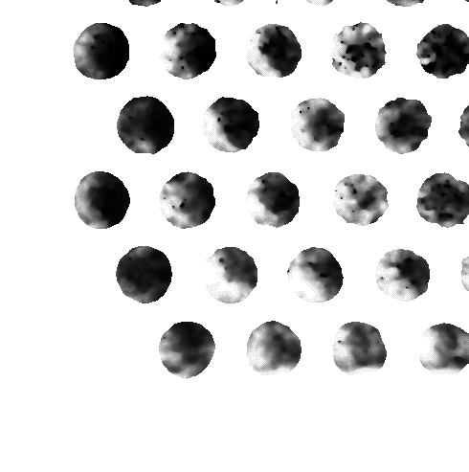

**Figure 15:**  **Stack of images after applying mask and histogram equalisation**

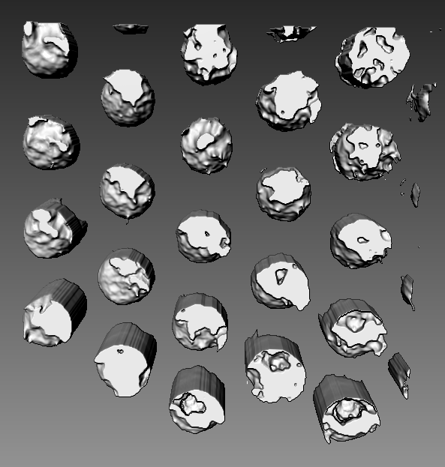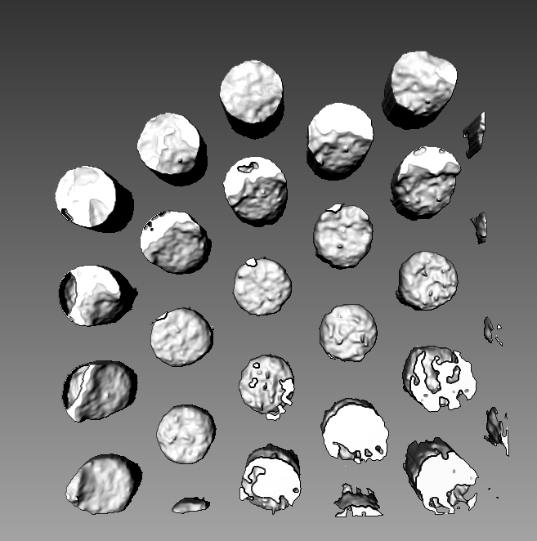

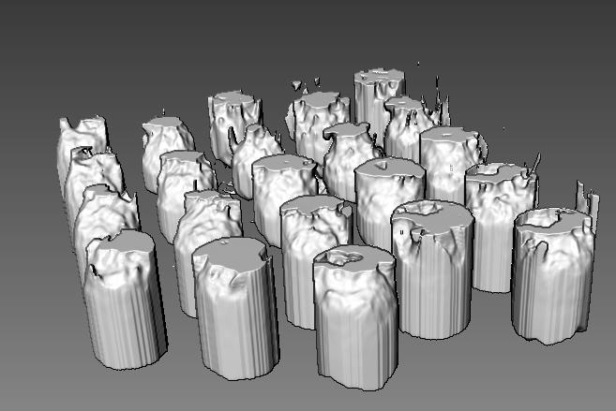

**Figure 16: 3D render after apply histogram equalisation and masking (threshold value = 0-68)**

After applying masking to the histogram equalised stack of images, the result is much better than the original image. The balls are not connected to each other, and all the balls can be seen at threshold 0-68. However the top surface is flattened due to the darker images that form the top layer.

From what we have seen, applying global histogram equalization then applying a mask to remove the background is a good solution. To improve upon the histogram equalization, I tried to implement Contrast Limited Adaptive Histogram Equalization (CLAHE) to equalize the stack of images. CLAHE is a variant of Adaptive histogram equalization (AHE) which takes care of over-amplification of the contrast (Infoaryan, n.d.). CLAHE operates on small regions in the image, called tiles, rather than the whole image. The neighboring tiles are then combined using bilinear interpolation to remove the artificial boundaries. The result is overall better contrast in pictures with various intensities in different areas in the image. As we can see in Figure 17, in the first few stacks of images it is lighter than the ones using global histogram equalisation (Figure 15). This makes it more accurate to the original images. The rest of the stack looks almost similar to each other. The result in 3D render (Figure 17) is the top surface there is more texture instead of just flat surface like in Figure 16. Overall it produces the best results among the methods I have tried so far.

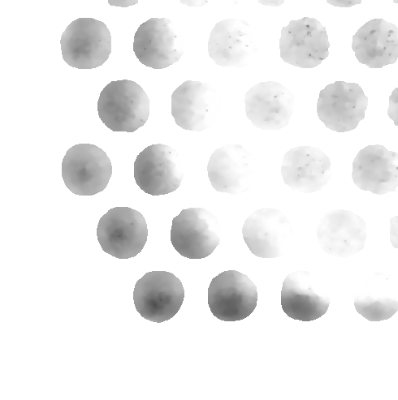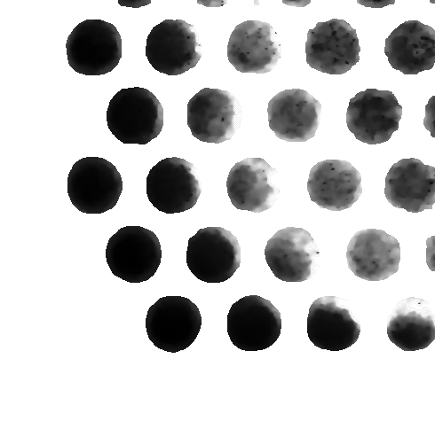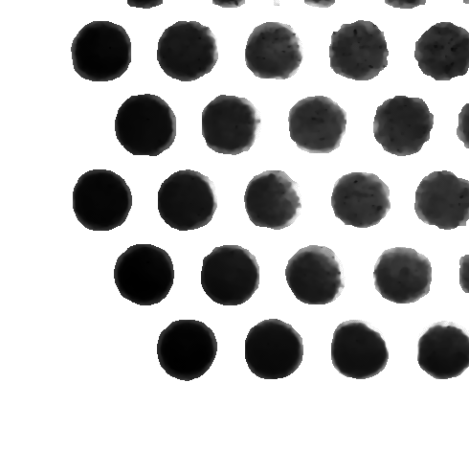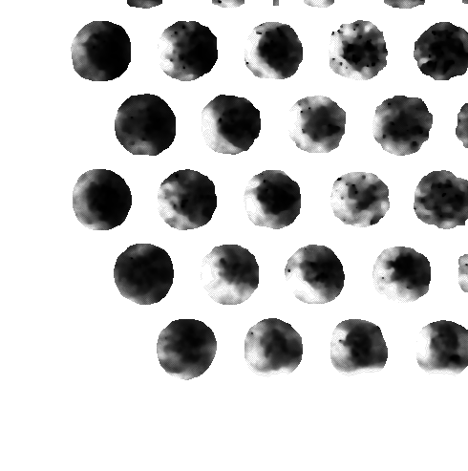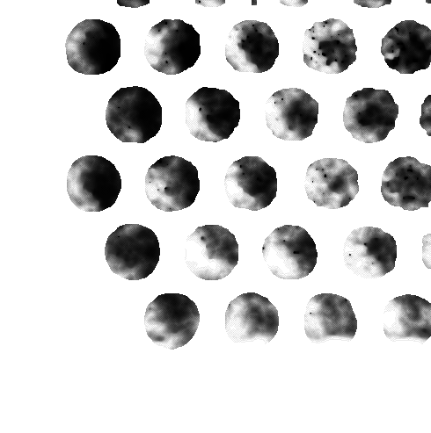

Figure 17: **Stack of images after applying mask and CLAHE histogram equalization**

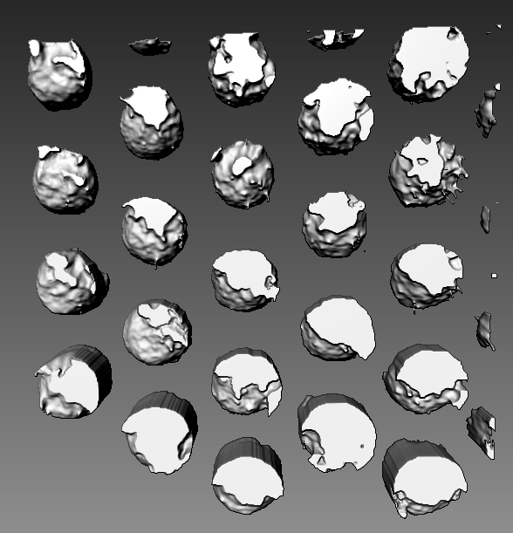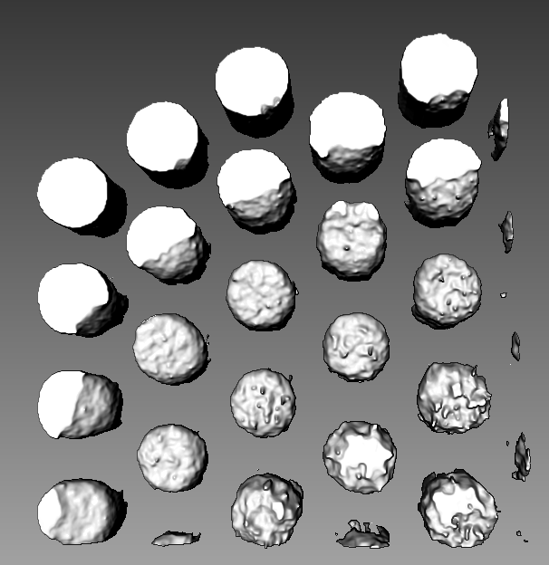

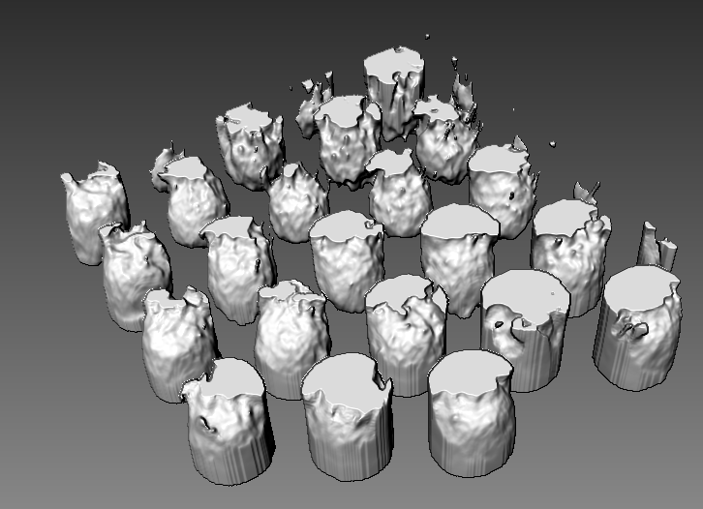

**Figure 18: 3D render after apply CLAHE histogram equalisation and masking (threshold value = 0-68)**

**Conclusion**

Overall, the 3D render output has been improved. After using various methods, applying CLAHE histogram equalisation and masking produces the best results so far. However the 3D render does not represent the ball grid arrays accurately enough like the first example given, so it will be hard for the operator to check defects. This is a good progress towards improving the 3D render but much more has to be done to improve the 3D render to a usable level.

**Reference**

1. The institute for digital archaeology. (n.d.). *The Science of 3D Rendering*. Retrieved from <http://digitalarchaeology.org.uk/the-science-of-3d-rendering/>.
2. OpenCV. (n.d.). *Image Inpainting*. Retrieved from

<https://docs.opencv.org/master/df/d3d/tutorial_py_inpainting.html>

1. Infoaryan. (n.d.). *CLAHE Histogram Equalization – OpenCV*. Retrieved from

<https://www.geeksforgeeks.org/clahe-histogram-eqalization-opencv/>

1. OpenCV. (n.d.). Histogram Equalization. Retrieved from

<https://docs.opencv.org/3.4/d4/d1b/tutorial_histogram_equalization.html>